# Use Case Template

Version 1.20

## Revision History

|  |  |  |
| --- | --- | --- |
| Date | Author | Description of change |
| 03/19/2019 | Jesse Sanchez | Create Initial Draft |
|  |  |  |
|  |  |  |

**Use Case:** Sign into Lecture

**Id**: UC- UseCaseAttendanceSystem

**Description:** Student electronically signs into lecture through a smart card system.

**Level:** User Goal

**Primary Actor:** Student

**Supporting Actors:** Lecturer and Administrators

**Stakeholders and Interests:**

Parents- Wants to make sure their kids attend classes.

**Pre-Conditions:** Student must be enrolled in specific lecture.

**Post Conditions**

Success end condition: Student successfully signs into lecture with smart card.

Failure end condition: Student cannot sign into lecture with smart card.

Minimal Guarantee: Student records remain private.

**Trigger:** Student attends lecture.

## Main Success Scenario

1. Student enrolls in course/lecture.
2. Students signs into lecture.
3. Students signs out of lecture.

## Extensions

In step 2., if student cannot sign into lecture with smart card.

1. Enter lecture.
2. Sign back-up paper sign-in sheet.

## Variations None

**Frequency:** Depends on lecture roster

## Special Requirements

Security

1.Student personal information is protected.

## Issues

1. Student must have smart card every class.
2. Electronic card reader works correctly.



**Use Case:** Create Lecture Roster

**Id**: UC- UseCaseAttendanceSystem

**Description:** Lecturer creates lecture electronically with roster.

**Level:** High

**Primary Actor:** Lecturer

**Supporting Actors:** Student and Administrators

**Stakeholders and Interests:**

School officials – Wants to know lectures are being completed as scheduled.

**Pre-Conditions:** Lecturer agrees to conduct lecture.

**Post Conditions**

Success end condition: Lecturer able to create electronic roster for lecture.

Failure end condition: Lecturer cannot create an electronic roster for lecture.

Minimal Guarantee: Lecturer conducts lecture whether electronic roster is created or not.

**Trigger:** Student enroll in courses where lecture will be performed.

## Main Success Scenario

1. School creates courses where lecture will be performed.
2. Lecturer agrees to perform assigned lecture.
3. Lecturer creates electronic roster for students electronically sign in.

## Extensions

In step 3., if lecturer cannot create electronic roster

1. Lecturer prints paper sign in sheet.
2. Students sign in on the paper sheet.

## Variations None

**Frequency:** Once per lecture.

## Special Requirements

Security

1.Student personal information is protected.

## Issues

1. System must be working correctly.

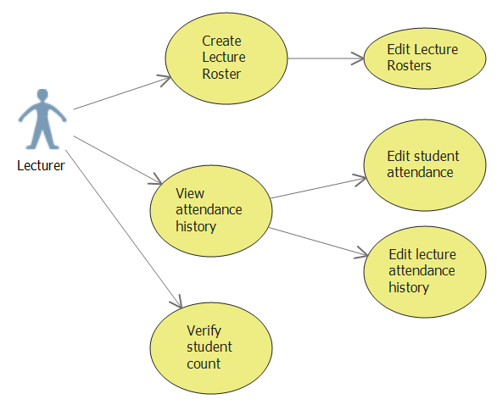

**Use Case:** Add students to database

**Id**: UC- UseCaseAttendanceSystem

**Description:** Administratorsadd enrolled students to school database roster.

**Level:** High Level

**Primary Actor:** Administrators

**Supporting Actors:** Students

**Stakeholders and Interests:**

Parents- Wants to make sure their kids are enrolled.

**Pre-Conditions:** Students enroll in school where smart card will be used.

**Post Conditions**

Success end condition: Student are added to school database.

Failure end condition: Administrators cannot add students to database due to system or student enrollment issues.

Minimal Guarantee: Student records remain private.

**Trigger:** Student enroll in school.

## Main Success Scenario

1. Students enrolls in school.
2. Administrators add students to database of students.
3. Students are provided with smart cards.

## Extensions None

## Variations None

**Frequency:** Once per student.

## Special Requirements

Security

1.Student personal information is protected.

## Issues

1. Student must be accepted enroll in school.

